Project Design Phase-II
Data Flow Diagram & User Stories

Date | 26 August 2026
Project Name | Employee Raise Issues
Maximum Marks | 4 Marks

Data Flow Diagrams:
A Data Flow Diagram (DFD) is a visual representation of how data moves through the Employee Raise Issue System. It shows how employees submit raise-related issues, how the system stores and processes the information, and how HR/Managers review and resolve those issues.
Example: (Simplified)
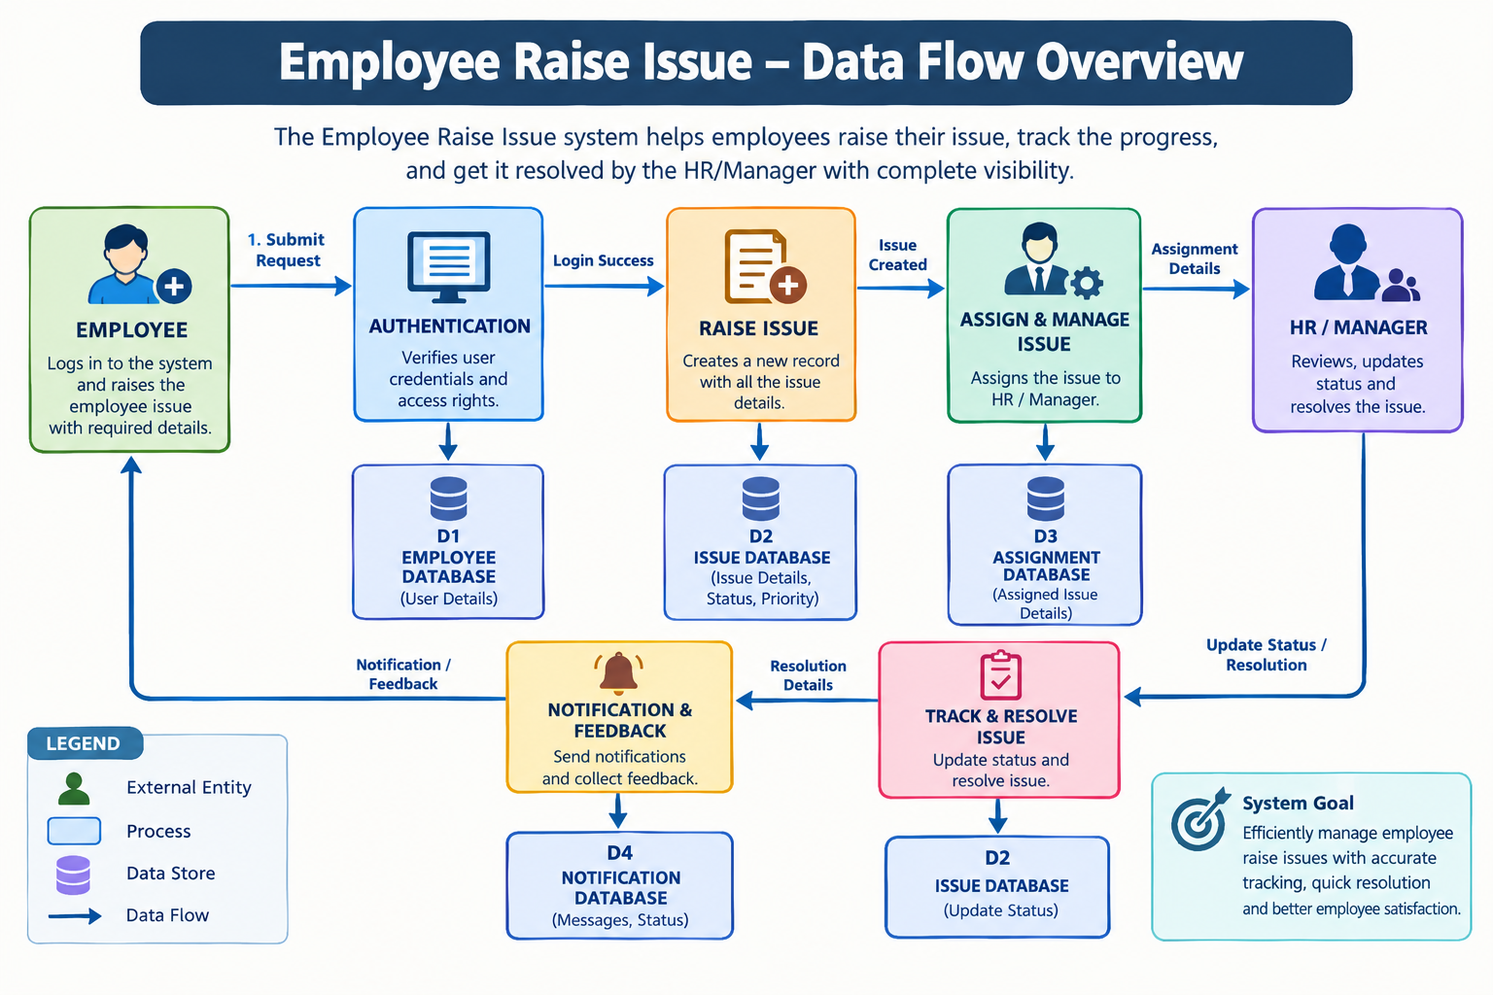
User Stories
Use the below template to list all the user stories for the product.
User Type | Functional Requirement (Epic) | User Story Number | User Story / Task | Acceptance Criteria | Priority | Release
Employee | Registration & Login | USN-1 | As an employee, I can register using my basic details so that I can access the application. | Employee can register and access the dashboard. | High | Sprint-1
Employee | Login | USN-2 | As an employee, I can log in using my email and password. | Valid credentials allow successful login. | High | Sprint-1
Employee | Raise Issue | USN-3 | As an employee, I can submit a salary raise issue with details and supporting information. | Issue is submitted and a unique Issue ID is generated. | High | Sprint-1
Employee | Track Issue | USN-4 | As an employee, I can track the status of my raise issue. | Current status such as Pending, Under Review, Approved, or Rejected is displayed. | High | Sprint-2
Employee | Notifications | USN-5 | As an employee, I can receive notifications when my issue status changes. | Employee receives status-update notifications. | Medium | Sprint-2
HR/Manager | Issue Management | USN-6 | As an HR/Manager, I can view employee raise issues submitted to me. | HR/Manager can view complete issue details. | High | Sprint-1
HR/Manager | Review & Resolution | USN-7 | As an HR/Manager, I can review and update the status of an employee raise issue. | HR/Manager can approve, reject, or request further information. | High | Sprint-2
HR/Manager | Communication | USN-8 | As an HR/Manager, I can provide comments or feedback on an issue. | Comments are saved and visible to the employee. | Medium | Sprint-2
Administrator | User Management | USN-9 | As an administrator, I can manage employee and HR/Manager accounts. | Administrator can add, update, or deactivate accounts. | Medium | Sprint-3
Administrator | Reports | USN-10 | As an administrator, I can view reports of employee raise issues. | Reports show issue counts, statuses, and resolutions. | Medium | Sprint-3

